**Project Design Phase-I**

**Problem Solution Fit**

|  |  |
| --- | --- |
| **Team ID** | **PNT2022TMID20252** |
| **Project Name** | **IoT based smart crop protection system for agriculture** |

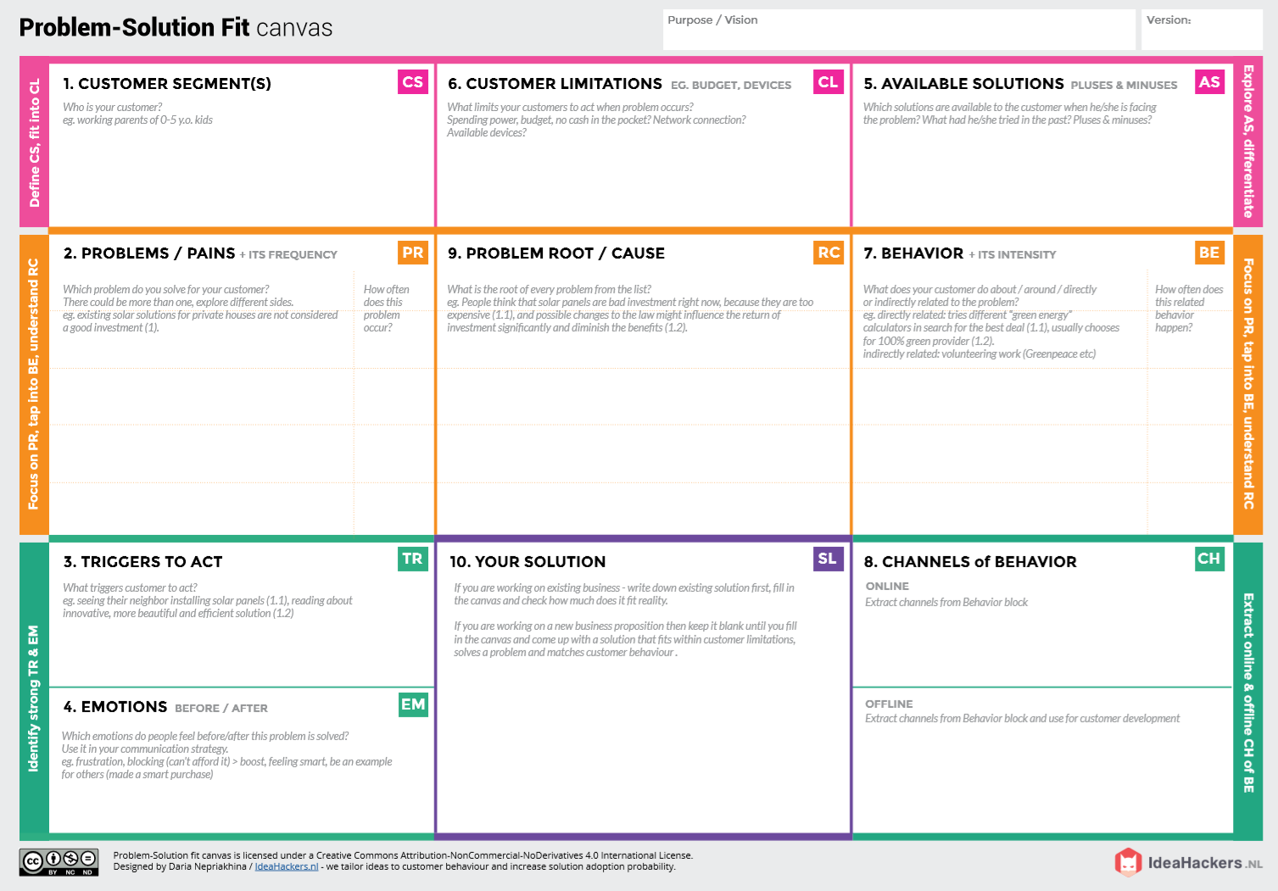

**OFFLINE**: The control action is taken by the farmers to monitor the farms.

**ONLINE:** The Data is sent to the application through the sensors for the farmers

**Direct related**: A solution using Iot to solve this problem

**Indirect related**: Internet connectivity may not be strong in rural areas so the data transmission speed may be slow

Monitor different parameters like pH temperature, any movement of animals and an application is made to retrive data easily from the farm using IOT.

***“IoT based Smart crop protection system for agriculture”***

It provides more yield by protecting crops from pests, diseases and weeds as well as animals and heavy rainfall.

1)Any intrusion of animals may destroy the crops and pave way to heavy loss

2)If it results in less productivity, it will affect in farmer’s profit.

* High maintanence costs
* Security of data
* It is difficult to monitor and control the farm
* Not sure if it works under all climatic conditions

Farmers and owners who are not near their field

Finding solutions to improve the rural life and ease their way of farming

**BEFORE**: Debts, heavy manual work, difficult to monitor

**AFTER**: It will provide more yield in the field